Network Segmentation Strategy
Andree Salvo
Southern New Hampshire University
CYB 220-10030 – 6-2 Project Two
Instructor: Wesley Buchan

Network Segmentation Strategy
- Configuration
- Host-based firewall policy

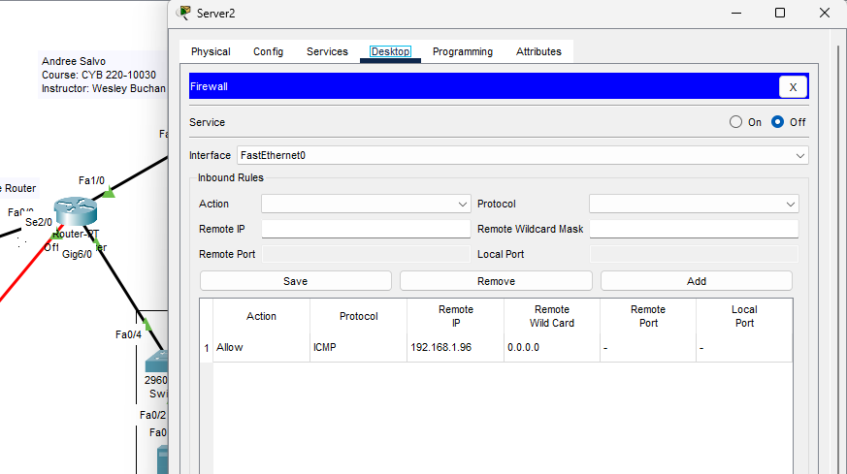
- FTP Server
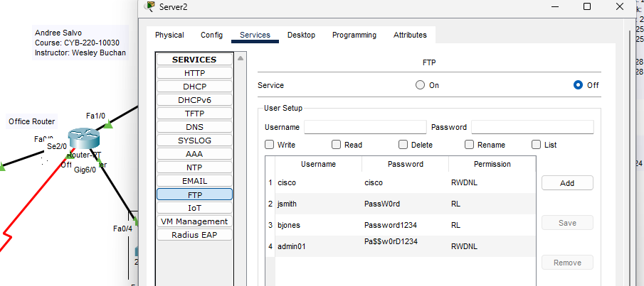

- Network-based firewall policy
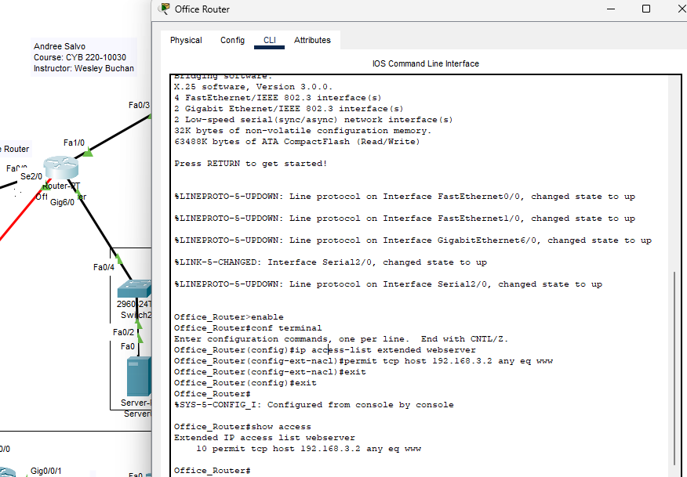

- Rationale
- The network was separated from the FTP server, this rule was created by only allowing traffic from the IP address from the admin network through its firewall. When this rule is in place the server will only allow traffic from the admin network. Moreover, this would block sorts of traffic from the other IP addresses.

- The least privilege is only assigned to users based on their role, whether its granting access or denying access. From the configuration FTP server, “Jsmith and Bjones” were the only two people who only had read/list access, while “admin01” has full administrative access rights. This helps minimize risk and prevents anyone trying to tamper with the network.

- A firewall based on a network helps isolate traffic by determining what devices can communicate with each other. In this case, the firewall rules (ACLs) is intended that only the admin network can only reach the FTP server and that only the kiosk can communicate with the web server on port 80. This keeps the services separated and reduces the chances that someone will log in and mess around with something they shouldn't.

